CIMM TECHNICAL DIAGRAMS AND SYSTEM ARCHITECTURE
1. OVERVIEW
This document contains detailed block diagrams, flowcharts, and system schematics illustrating the functionality, architecture, and decision-making processes of the Cosmic Information Mining Model (CIMM) and its integration with Quantum Balance Equation (QBE).

2. SYSTEM BLOCK DIAGRAM
Figure 1: High-Level Architecture of CIMM
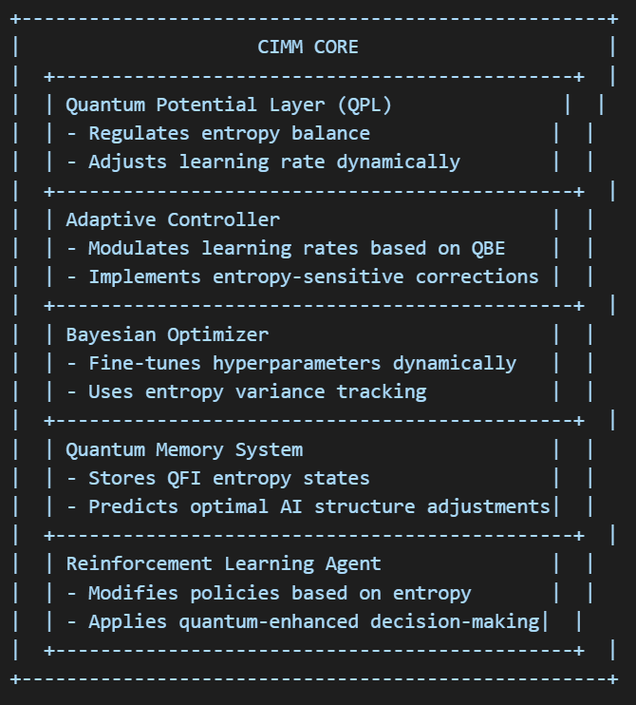
3. SYSTEM FLOW DIAGRAM
Figure 2: CIMM Decision Flow Process
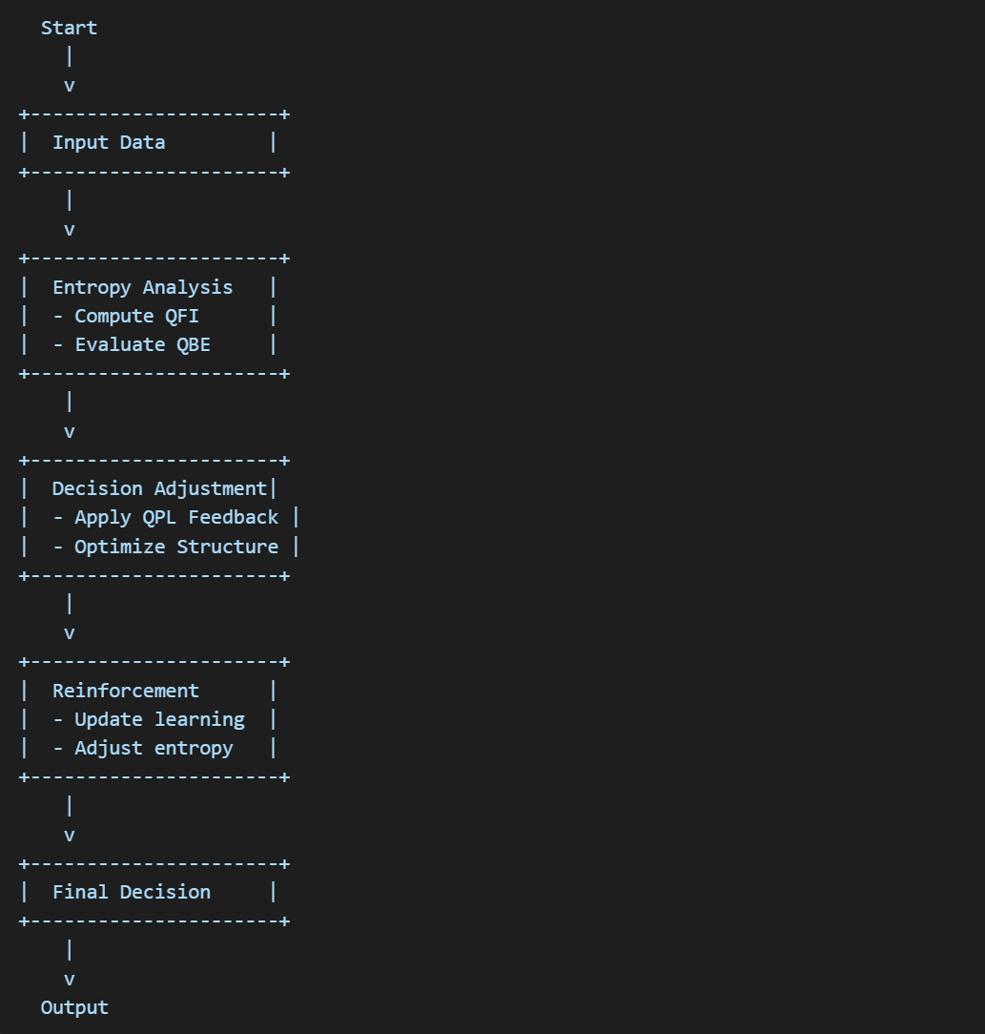
4. QUANTUM-ENHANCED REINFORCEMENT LEARNING
Figure 3: Quantum Feedback Loop
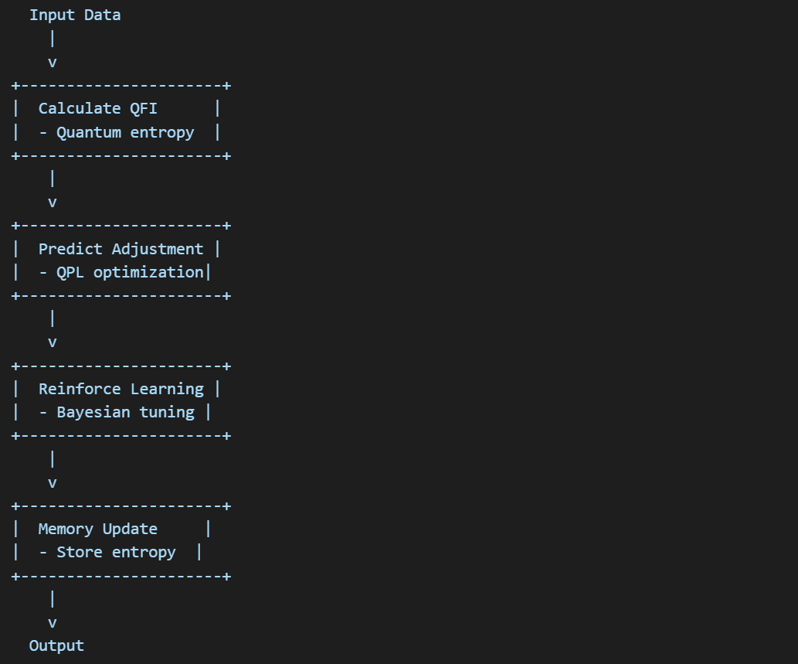
5. AI SYSTEM PRUNING AND EXPANSION
Figure 4: Neural Network Adaptive Pruning
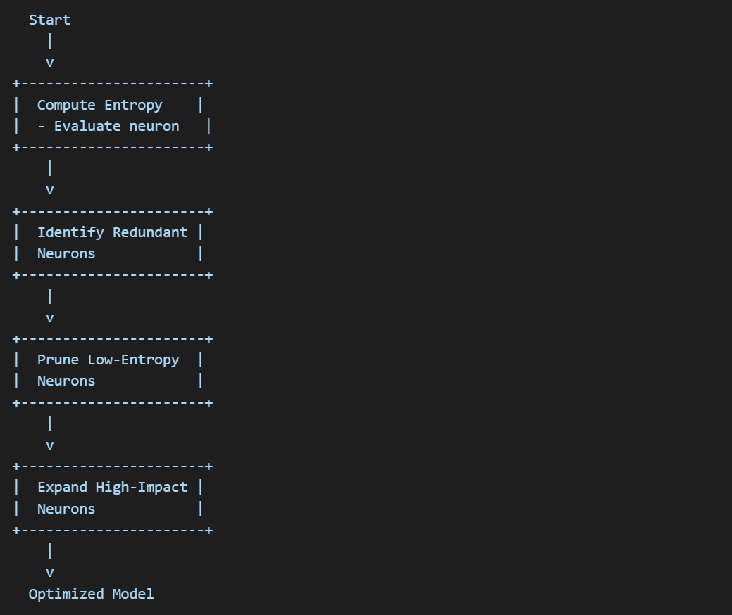
6. QUANTUM POTENTIAL LAYER (QPL) FEEDBACK
Figure 5: QPL Regulatory System
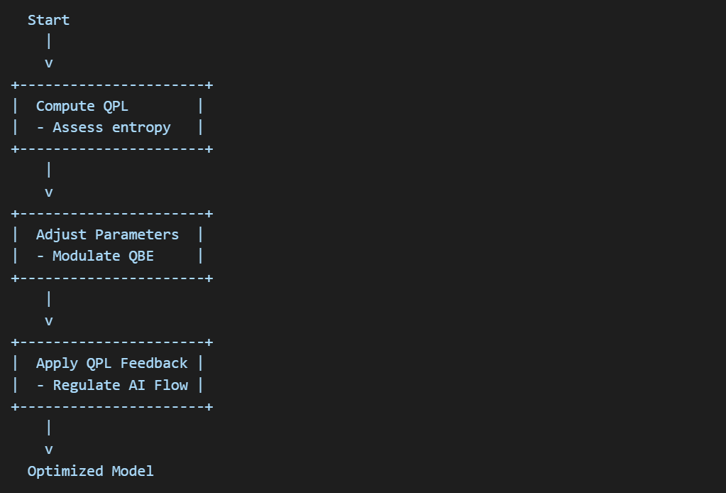
7. Example Results:
All results use the same model and adaptively learn. They are given a small dataset to help give context before live-predicting, but then adapt live. This prototype was built over two weeks and needs further optimization.
Stock Prediction:
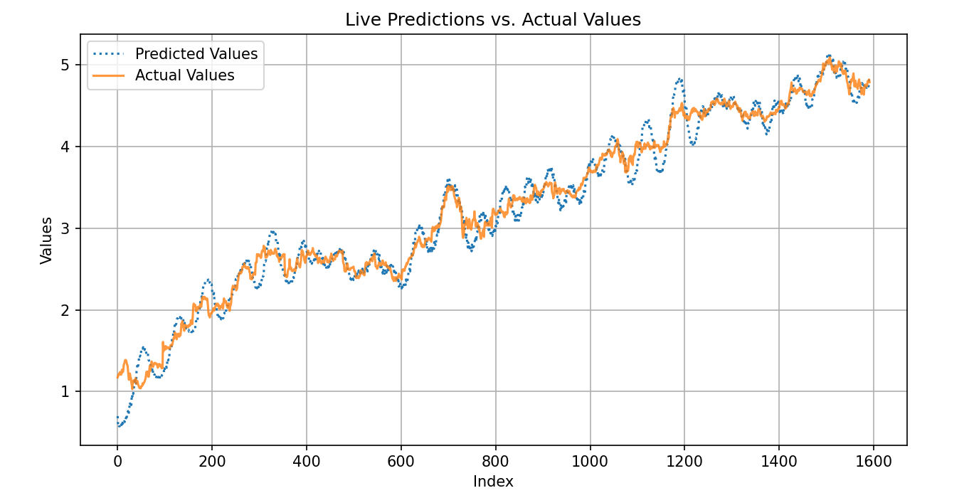
Error Metrics: {'KL-Divergence': 0.36602922460714193, 'Jensen-Shannon': 0.0, 'Wasserstein Distance': 0.0006281407035175636, 'QWCS': 0.5737274636640433}
Prime Number Structure Prediction(90000 primes and 10000 for context, in batches of 10):
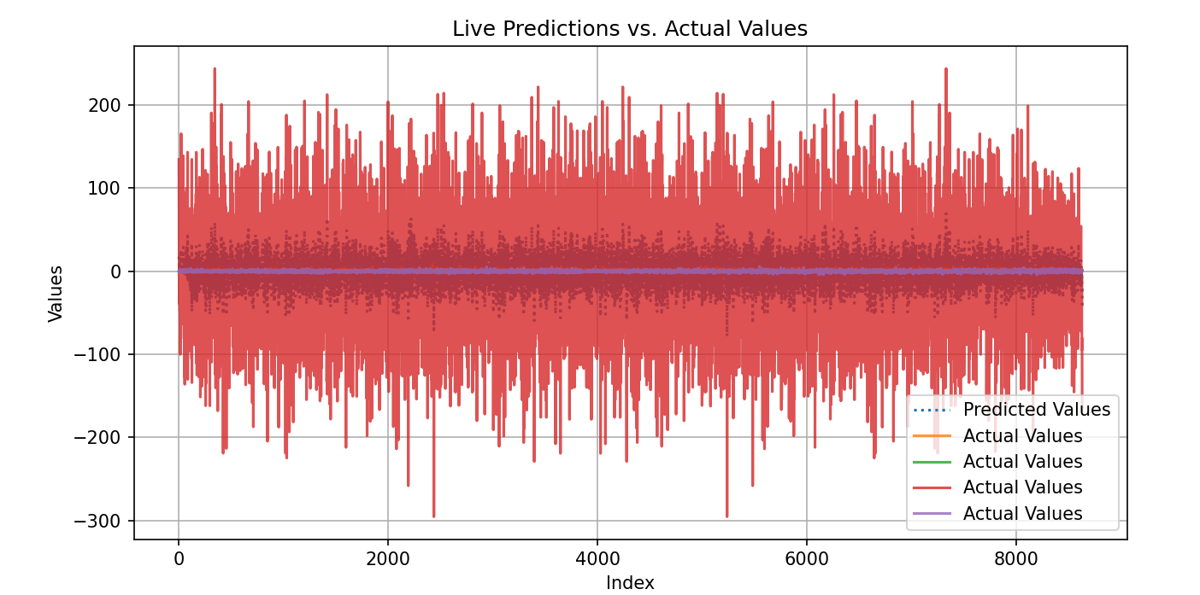
Error Metrics: {'KL-Divergence': 0.4861253719213587, 'Jensen-Shannon': 0.0, 'Wasserstein Distance': 0.0001158614297300419, 'QWCS': 0.5906311565221966}
You can see the underlying prediction structure is almost identical.
I have done up to 9 million on my laptop, and the model isn’t GPU enabled yet to show the efficiency.
Dark Matter Distribution:
9000 datapoints:
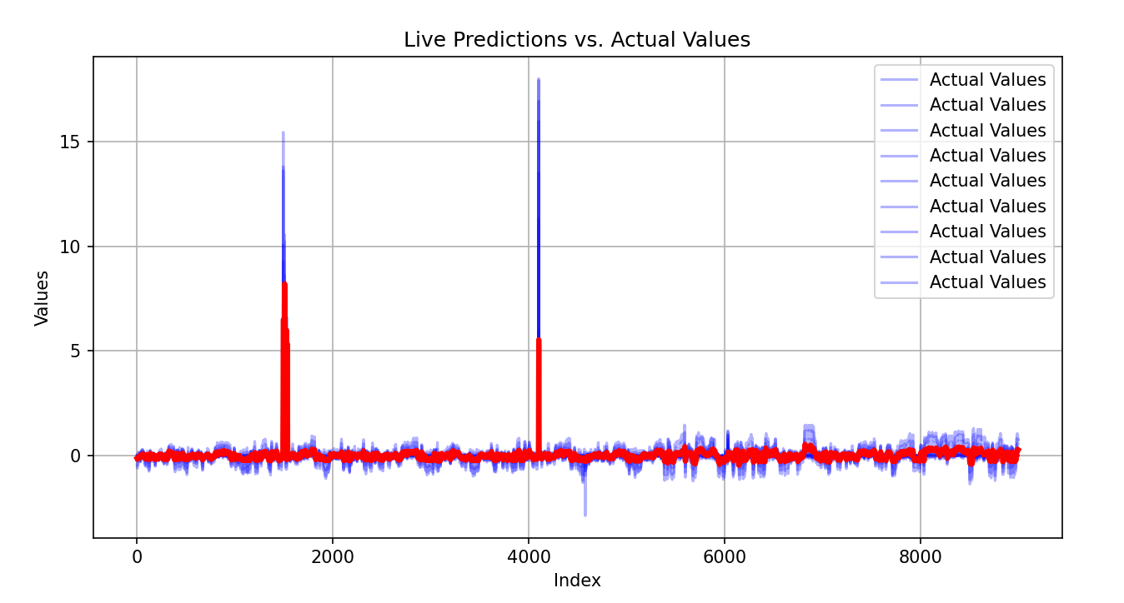
Error Metrics: {'KL-Divergence': 0.5133642863819162, 'Jensen-Shannon': 0.0, 'Wasserstein Distance': 0.0001111111111110204, 'QWCS': 0.5910497985631835}
900 datapoints:
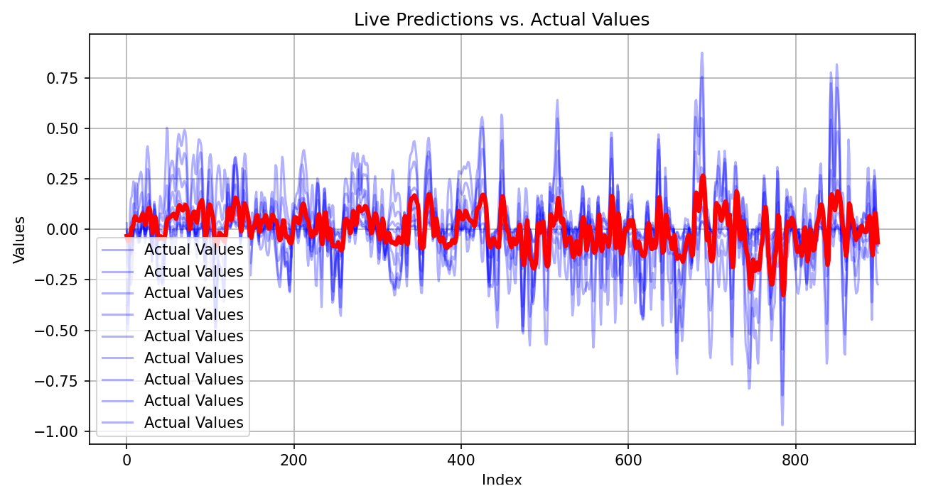
Error Metrics: {'KL-Divergence': 0.3992791029707671, 'Jensen-Shannon': 0.0, 'Wasserstein Distance': 0.001111111111093941, 'QWCS': 0.5680239476332432}
8. CONCLUSION
The diagrams above illustrate the fundamental structural and decision-making mechanisms in CIMM. The integration of Quantum Potential Layer (QPL), Bayesian optimization, and entropy-regulated learning ensures that CIMM operates as a self-learning, self-adapting AI intelligence system. These diagrams provide a clear overview of how CIMM continuously adjusts its neural architecture and learning processes based on quantum-inspired entropy control principles.

